**WEEK - 1**

**Aim : What is HTML ?And various tags in HTML**

**1.What is web programming?**

Web programming refers to the writing, markup and coding involved in Web development, which includes Web content, Web client and server scripting and network security. The most common languages used for Web programming are XML, HTML, JavaScript, Perl 5 and PHP. Web programming is different from just programming, which requires interdisciplinary knowledge on the application area, client and server scripting, and database technology.

HTML5 and CSS3 supports most of the client-side functionality provided by other application frameworks.

**2.What is full form of HTML ? and what is its version?**

* HYPER TEXT MARKUP LANGUAGE .
* current version is HTML5

**3.How do we write code in HTML?**

<!DOCTYPE html>

<html>

<body>

<h1>My First Heading</h1>

<p>My first paragraph.</p>

</body>

</html>

**4.Difference b/w LAN,MAN & VAN**

* A LAN (local area network) is a group of computers and network devices connected together, usually within the same building.
* A MAN (metropolitan area network) is a larger network that usually spans several buildings in the same city or town.
* A WAN (wide area network), in comparison to a MAN, is not restricted to a geographical location, although it might be confined within the bounds of a state or country. A WAN connects several LANs, and may be limited to an enterprise (a corporation or an organization) or accessible to the public.

**5. Difference between physical address and logical address**

The logical address is a virtual address and can be viewed by the user. ... The fundamental difference between logical and physical address is that logical address is generated by CPU during a program execution whereas, the physical address refers to a location in the memory unit.

**6.What are h1-h6 tags in HTML?**

<!DOCTYPE html>

<html>

<body>

<h1>Heading 1</h1>

<h2>Heading 2</h2>

<h3>Heading 3</h3>

<h4>Heading 4</h4>

<h5>Heading 5</h5>

<h6>Heading 6</h6>

</body>

</html>

**OUTPUT :**

# **Heading 1**

## **Heading 2**

### **Heading 3**

#### **Heading 4**

##### **Heading 5**

###### **Heading 6**

**7. How many types of tags are there in HTML and what are they ?**

**1. Paired and Unpaired Tags**

**Paired Tags** :

<p> This text is a paragraph . </p>

**Unpaired Tags :**

<p> This is a paragraph </p>

<hr>

<i> <b> This is a bold and italicized text </b> </i>

**2. Self-Closing Tags**

<img src="a.jpg" alt="This is an alternate text">

**3. Utility-Based Tags:**

This is done using tags like <font>, <b>, <u>, etc. Tables, divisions, and span tags are also those tags that help format a web page or document and set the layout of the page.

**Control Tags**

Another category of tags that can be created is ‘Control Tags’. The Script tags, radio buttons or checkboxes, the Form tags, etc., forms the control tags

**8. what is a web page and what are the different types of web pages?**

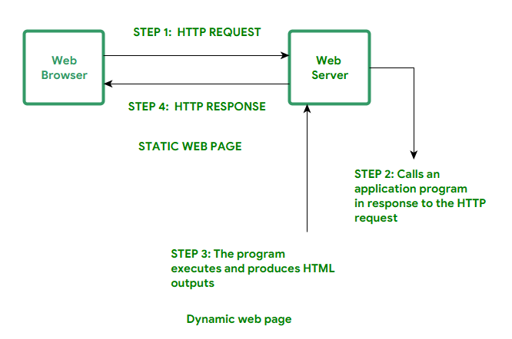

web page is a document available on world wide web. Web Pages are stored on web server and can be viewed using a web browser. A web page can cotain huge information including text, graphics, audio, video and hyper links. These hyper links are the link to other web pages

**Static Web pages:**

Static Web pages are very simple. It is written in languages such as HTML, JavaScript, CSS, etc. For static web pages when a server receives a request for a web page, then the server sends the response to the client without doing any additional process. And these web pages are seen through a web browser. In static web pages, Pages will remain the same until someone changes it manually.

**Dynamic Web Pages:**

Dynamic Web Pages are written in languages such as CGI, AJAX, ASP, ASP.NET, etc. In dynamic web pages, the Content of pages is different for different visitors. It takes more time to load than the static web page. Dynamic web pages are used where the information is changed frequently, for example, stock prices, weather information, etc.

**9.what is a website ?**

A website is a collection of web pages and related content that is identified by a common domain name and published on at least one web server. Notable examples are wikipedia.org, google.com, and amazon.com. All publicly accessible websites collectively constitute the World Wide Web

**CODE :**

<!DOCTYPE html>

<html>

<body>

<h1>Heading 1</h1>

<h2>Heading 2</h2>

<h3>Heading 3</h3>

<h4>Heading 4</h4>

<h5>Heading 5</h5>

<h6>Heading 6</h6>

</body>

</html>

**OUTPUT:**

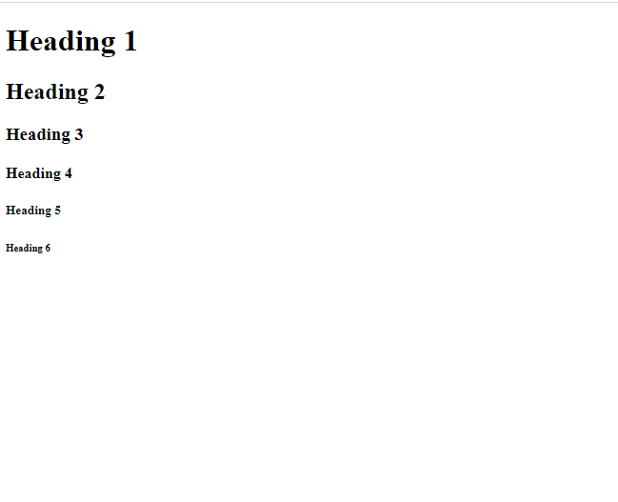

**WEEK – 2**

**Aim : Different HTML components and img tag in HTML.**

**1.** **what is the difference between head title and body in html**

**HTML Head**

Head is the first part of the HTML document that is used to add additional information to the HTML document.

Head contains meta information, the title of the page, internal style, external stylesheet link, internal javascript, external JavaScript file linking, etc.

**HTML Body**

Body is the part of HTML that contains the content of the page. The body section is the second section of the HTML document where the first section is head.

Everything that you see, read or hear on a browser lies in the body of HTML, like text, images, GIFs, videos, audios, etc.

**2.what is the difference between mobile application and web application**

**Native Apps:**

Native apps are installed onto the device itself and are developed especially for a particular mobile operating system. These apps are available on app stores such as Apple App Store, Google Play Store, etc.

**Web Apps:**

Web Apps can be accessed through the mobile device’s Web browser, Web Apps are based on internet-enabled applications. In order to access we don’t need to download and install the app onto a mobile device.

**3. various cateograies of tags in html**

The HTML tags can also be simply divided based on basic categories like **Basic HTML Root Tags, Formatting tags, Audio and Video Tags, Form and Input Tags, Frame Tags, Link Tags, List Tags, Table Tags, Style Tags, Meta Tags**, etc.

**1. Paired and Unpaired Tags**

**Paired Tags** : <p> This text is a paragraph . </p>

**Unpaired Tags :**

<p> This is a paragraph </p>

<hr>

<i> <b> This is a bold and italicized text </b> </i>

**2. Self-Closing Tags**

<img src="a.jpg" alt="This is an alternate text">

**3. Utility-Based Tags**

This is done using tags like <font>, <b>, <u>, etc. Tables, divisions, and span tags are also those tags that help format a web page or document and set the layout of the page.

**Control Tags**

Another category of tags that can be created is ‘Control Tags’. The Script tags, radio buttons or checkboxes, the Form tags, etc., forms the control tags

**CODE :**

<html>

<title>Rizwan's Resume</title>

<body style="background-color:#30bc9242; font-family: 'Open Sans', sans-serif">

<center><i><b><h1 style="color:red;text-decoration:underline">RESUME</h1></b></i></center> <p> I am Rizwan .I am 18 years old.I am passionate in coding.I know Programming languages like C,C++,Python3.I am currently studying B-Tech in vr siddhartha college,I did my intermediate from Sri Chaithanya jr college,I did my schooling from ravindra bharathi.My hobby is Photography.I love web development and i have made some awesome websites too and hosted it on github. In my free time i like to create good looking and responsive websites.I am always eager and curious to learn new technologies and use it to solve real life problems. </p>

<p><a href="https://www.codechef.com/users/rizwan_rockzz" target="_blank">CodeChef</a></p>

<p><a href="https://github.com/rizwanrockzz" target="_blank">Github</a></p>

<p><a href="https://www.facebook.com/profile.php?id=100007692646978"target="_blank">Facebook</a></p>

<p><a href="https://www.linkedin.com/in/rizwanullah-mohammad/" target="_blank">Linkedin</a></p>

<p><a href="https://www.rizwanrockzz.tech" target="_blank">My Website</a></p>

</body>

</html>

**OUTPUT :**

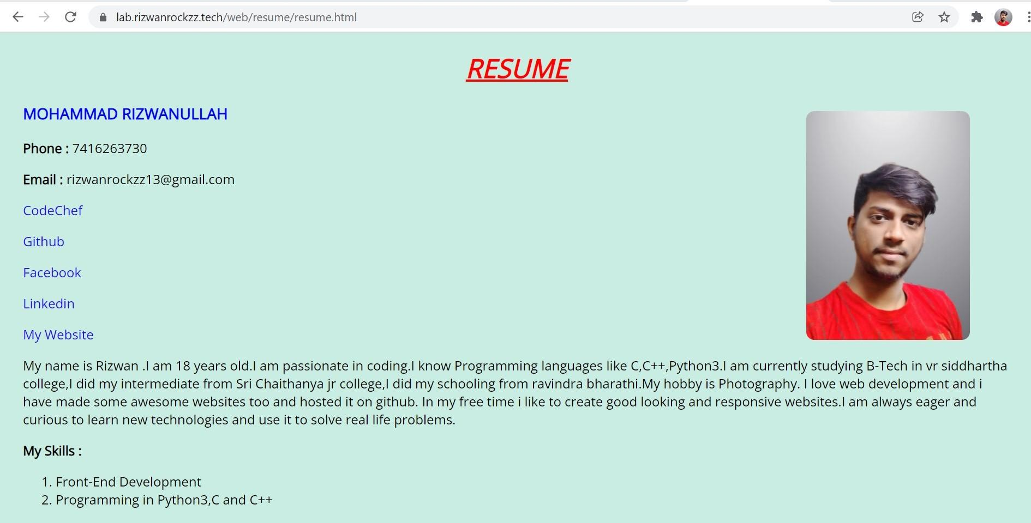

**WEEK-3**

**Aim : Types of Lists in HTML**

There are 2 types of lists and they are:

* Ordered Lists
* Unordered Lists

**Ordered Lists:**

* An ordered list starts with the <ol> tag. Each list item starts with the <li> tag.The list items will be marked with numbers by default.
* The HTML <ol> tag defines an ordered list. An ordered list can be numerical or alphabetical.

**Type attributes in Ordered list:**

|  |  |
| --- | --- |
| **Type** | **Description** |
| type="1" | The list items will be numbered with numbers (default) |
| type="A" | The list items will be numbered with uppercase letters |
| type="a" | The list items will be numbered with lowercase letters |
| type="I" | The list items will be numbered with uppercase roman numbers |
| type="i" | The list items will be numbered with lowercase roman numbers |

The type attribute of the <ol> tag, defines the type of the list item marker:

**Syntax: (ordered list)**

<ol type=””>

<li>………………………………….</li>

<li> …………………………………..</li>

<li>………………………………….</li>

<ol>

* Use the HTML <ol> element to define an ordered list
* Use the HTML type attribute to define the numbering type
* Use the HTML <li> element to define a list item

**Unordered List:**

* An unordered list starts with the <ul> tag. Each list item starts with the <li> tag.
* The list items will be marked with bullets (small black circles) by default
* The HTML <ul> tag defines an unordered (bulleted) list.

**Type attributes in unordered lists:**

|  |  |
| --- | --- |
| **Value** | **Description** |
| disc | Sets the list item marker to a bullet (default) |
| circle | Sets the list item marker to a circle |
| square | Sets the list item marker to a square |
| none | The list items will not be marked |

**Unordered lists syntax:**

<ul type=””>

<li>……………………………….</li>

<li>………………………………..</li>

<li>…………………………………</li>

<ul>

**Video Tag:**

The <video> tag is used to embed video content in a document, such as a movie clip or other video streams.

The <video> tag contains one or more [<source>](https://www.w3schools.com/tags/tag_source.asp) tags with different video sources. The browser will choose the first source it supports.

The text between the <video> and </video> tags will only be displayed in browsers that do not support the <video> element.

**Attributes in video tag:**

|  |  |  |
| --- | --- | --- |
| **Attribute** | **Value** | **Description** |
| [autoplay](https://www.w3schools.com/tags/att_video_autoplay.asp) | autoplay | Specifies that the video will start playing as soon as it is ready |
| [controls](https://www.w3schools.com/tags/att_video_controls.asp) | controls | Specifies that video controls should be displayed (such as a play/pause button etc). |
| [height](https://www.w3schools.com/tags/att_video_height.asp) | *pixels* | Sets the height of the video player |
| [loop](https://www.w3schools.com/tags/att_video_loop.asp) | loop | Specifies that the video will start over again, every time it is finished |
| [muted](https://www.w3schools.com/tags/att_video_muted.asp) | muted | Specifies that the audio output of the video should be muted |
| [poster](https://www.w3schools.com/tags/att_video_poster.asp) | *URL* | Specifies an image to be shown while the video is downloading, or until the user hits the play button |
| [preload](https://www.w3schools.com/tags/att_video_preload.asp) | auto metadata none | Specifies if and how the author thinks the video should be loaded when the page loads |
| [src](https://www.w3schools.com/tags/att_video_src.asp) | *URL* | Specifies the URL of the video file |
| [width](https://www.w3schools.com/tags/att_video_width.asp) | *pixels* | Sets the width of the video player |

**Syntax for Video tag:**

<video width = “ “ height = “ ” poster = “.png/.jpeg/url“ controls>

<source src = “url or path of file.mp4” type = “video/mp4”>

(or)

<source src = “url or path of file.ogg” type = “video/ogg”>

</video>

**Audio Tag:**

The <audio> tag is used to embed sound content in a document, such as music or other audio streams.

The <audio> tag contains one or more [<source>](https://www.w3schools.com/tags/tag_source.asp) tags with different audio sources. The browser will choose the first source it supports.

**Attributes in Audio tag:**

|  |  |  |
| --- | --- | --- |
| **Attribute** | **Value** | **Description** |
| [autoplay](https://www.w3schools.com/tags/att_audio_autoplay.asp) | autoplay | Specifies that the audio will start playing as soon as it is ready |
| [controls](https://www.w3schools.com/tags/att_audio_controls.asp) | controls | Specifies that audio controls should be displayed (such as a play/pause button etc) |
| [loop](https://www.w3schools.com/tags/att_audio_loop.asp) | loop | Specifies that the audio will start over again, every time it is finished |
| [muted](https://www.w3schools.com/tags/att_audio_muted.asp) | muted | Specifies that the audio output should be muted |
| [preload](https://www.w3schools.com/tags/att_audio_preload.asp) | auto metadata none | Specifies if and how the author thinks the audio should be loaded when the page loads |
| [src](https://www.w3schools.com/tags/att_audio_src.asp) | *URL* | Specifies the URL of the audio file |

**Syntax for Audio Tag:**

<audio controls>

<source src = “url or path of file.mp3” type = “audio/mpeg”>

(or)

<source src = “url or path of file.ogg” type = “audio/ogg”></audio>

**CODE :**

<html>

<body>

<center> <h1> Types of Lists in HTML </h1> </center>

<h2 style="text-decoration:underline"> Ordered Lists : </h2>

<h3> Most Used Apps : </h3>

<ol>

<li>Youtube</li>

<li>Whatsapp</li>

<li>Tik Tok</li>

<li>Facebook</li>

<li>Instagram</li>

<li>Snapchat</li>

<li>Pintrest</li>

</ol>

<h3> Friends : </h3>

<ol type="A">

<li>Ajay</li>

<li>MJNV</li>

<li>Charan</li>

<li>Mounav</li>

<li>Srinivas</li>

<li>Prabhu</li>

</ol>

<h3> MotorCycles : </h3>

<ol type="a">

<li>Hero</li>

<li>Honda</li>

<li>Activa</li>

<li>TVS</li>

</ol>

<h3> Operating Systems : </h3>

<ol type="I">

<li>Android</li>

<li>Windows</li>

<li>Linux</li>

<li>Mac</li>

</ol>

<h3> Cars : </h3>

<ol type="i">

<li>BMW</li>

<li>Ferrari</li>

<li>Bhugati</li>

<li>Audi</li>

<li>Suzuki</li>

</ol>

<h2 style="text-decoration:underline"> Unordered Lists : </h2>

<h3> My Skills </h3>

<ul>

<li>Coding in C,C++,Python</li>

<li>Web Programming</li>

<li>Logo Making</li>

<li>Android Development</li>

</ul>

<h3> Milk Products </h3>

<ul style="list-style-type:circle">

<li>Curd</li>

<li>Lussi</li>

<li>Butter Milk</li>

<li>Panneer</li>

<li>Cheese</li>

</ul>

<h3> Mobile Phone Companies </h3>

<ul style="list-style-type:square">

<li>Apple</li>

<li>Vivo</li>

<li>Oppo</li>

<li>Redmi</li>

<li>Poco</li>

</ul>

</body>

</html>

**OUTPUT :**

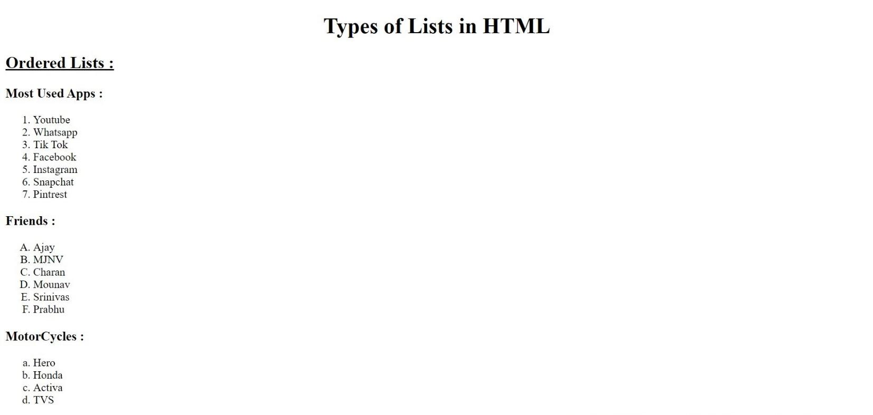

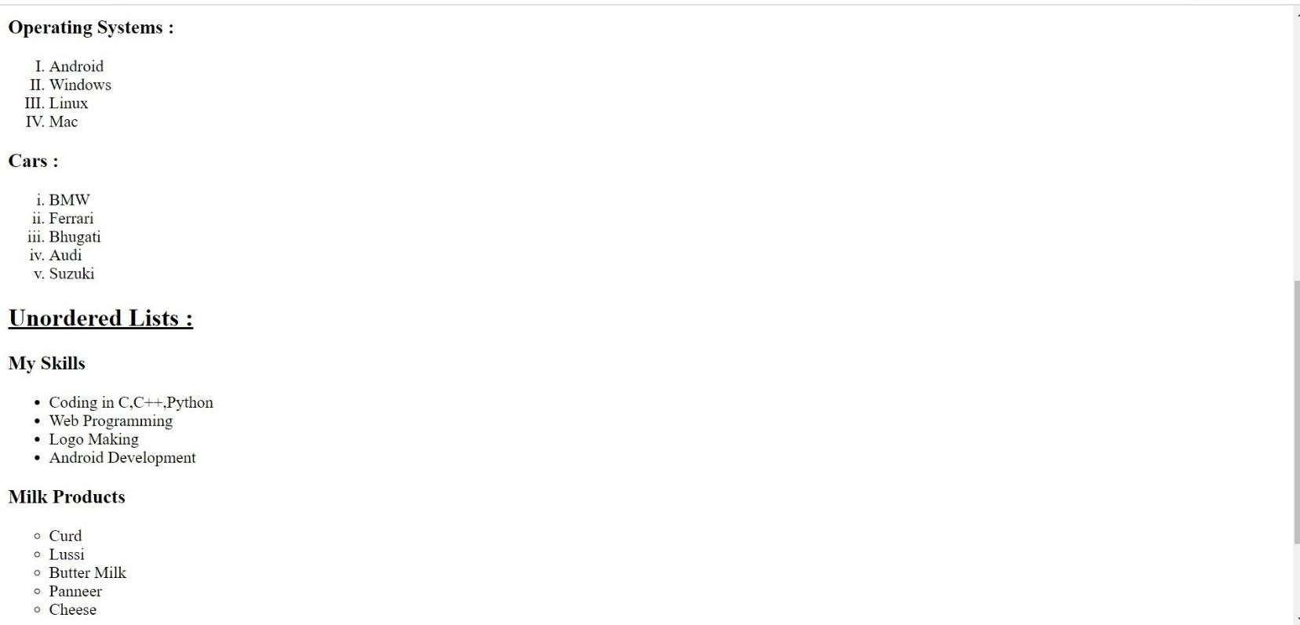



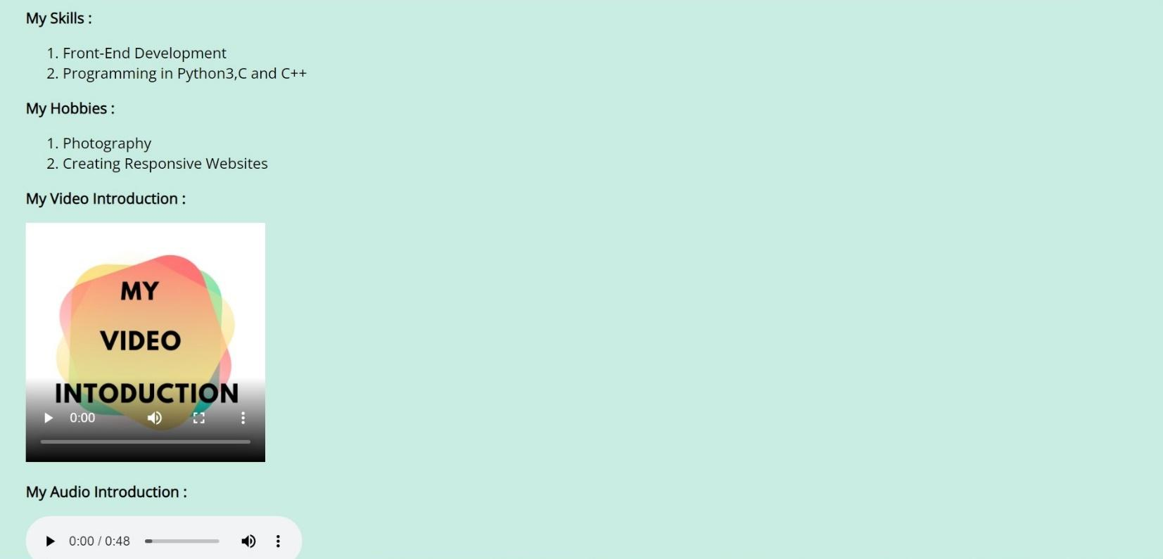

**WEEK - 4**

**Aim : Frameset Tag in HTML.Divide page into different frames**

**Frameset:**

The <frameset> tag in HTML is used to define the frameset. The <frameset> element contains one or more frame elements. It is used to specify the number of rows and columns in frameset with their pixel of spaces. Each element can hold a separate document.

**Attributes in Frameset:**

**cols**: The cols attribute is used to create vertical frames in a web browser. This attribute is basically used to define the no. of columns and their size inside the frameset tag.

**rows:** The rows attribute is used to create horizontal frames in the web browser. This attribute is used to define the no. of rows and their size inside the frameset tag.

**border:** This attribute of frameset tag defines the width of the border of each frame in pixels. Zero value is used for no border.

**frameborder:** This attribute of frameset tag is used to specify whether a three-dimensional border should be displayed between the frames or not for this use two values 0 and 1, where 0 defines no border and value 1 signifies for yes there will be a border.

**framespacing:** This attribute of frameset tag is used to specify the amount of spacing between the frames in a frameset. This can take any integer value as a parameter which basically denotes the value in pixel.

**Syantax For Column’s Division:**

<frameset cols = “n1%, n2%, n3%>

<frame name = “top” src = “first file.html” />

<frame name = “main” src = “second file.html” />

<frame name = “bottom” src = “third file.html” />

<noframes>

<body>

You can write here documentation.

n1,n2,n3 are the division of web-page percentages.

</body>

</noframes>

</frameset>

**Syantax For Row’s Division:**

<frameset rows = “n1%, n2%, n3%>

<frame name = “top” src = “first file.html” />

<frame name = “main” src = “second file.html” />

<frame name = “bottom” src = “third file.html” />

.

.

<noframes>

<body>

You can write here documentation.

n1,n2,n3 are the division of web-page percentages.

</body>

</noframes>

</frameset>

**CODE:**

<html>

<frameset frameborder="0" border="0" cols="30%,70%">

<frame src="left.html">

<frame src="middle.html">

</frameset>

</html>

**OUTPUT :**

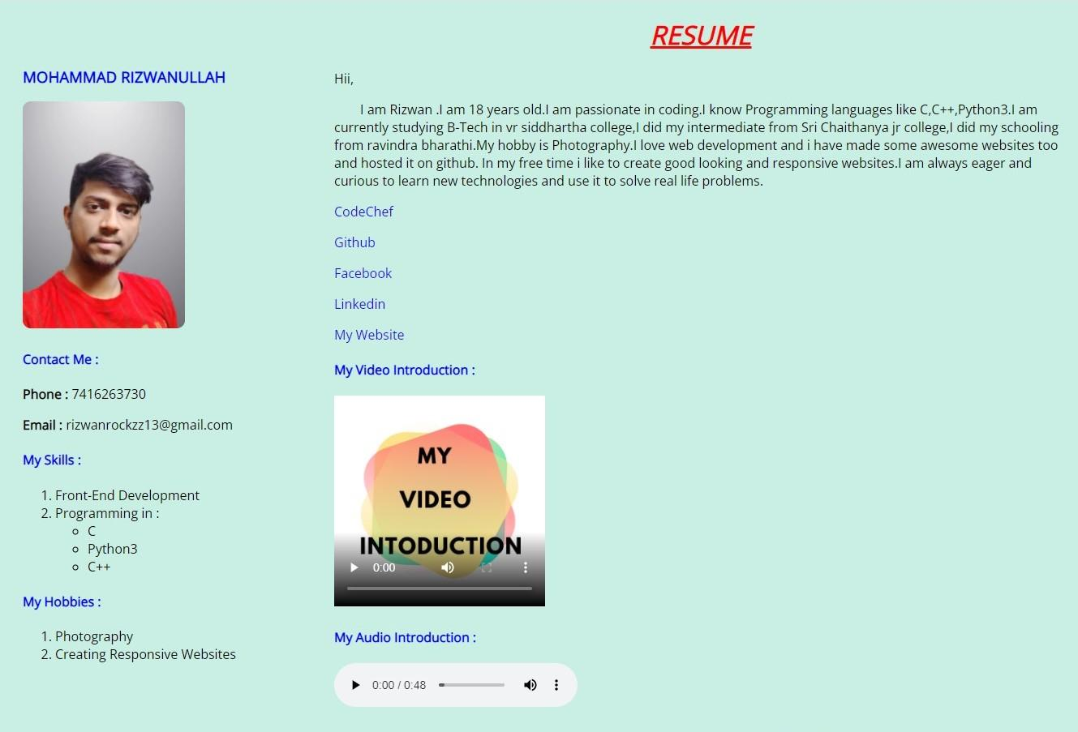

**WEEK-5**

**Aim : Table Tag in HTML and it’s methods.**

* HTML tables allow web developers to arrange data into rows and columns.
* The HTML tables are created using the **<table>** tag in which the **<tr>** tag is used to create table rows and **<td>** tag is used to create data cells. The elements under <td> are regular and left aligned by default

**Table Heading:**

* Table heading can be defined using **<th>** tag. This tag will be put to replace <td> tag, which is used to represent actual data cell. Normally you will put your top row as table heading as shown below, otherwise you can use <th> element in any row.

|  |  |
| --- | --- |
| **Tag** | **Description** |
| [<table>](https://www.w3schools.com/tags/tag_table.asp) | Defines a table |
| [<th>](https://www.w3schools.com/tags/tag_th.asp) | Defines a header cell in a table |
| [<tr>](https://www.w3schools.com/tags/tag_tr.asp) | Defines a row in a table |
| [<td>](https://www.w3schools.com/tags/tag_td.asp) | Defines a cell in a table |
| [<caption>](https://www.w3schools.com/tags/tag_caption.asp) | Defines a table caption |

**CODE:**

<!DOCTYPE html>

<html>

<head>

<title>Rizwan's Resume</title>

<style>

@import url("https://fonts.googleapis.com/css2?family=Lato&family=Open+Sans&display=swap");

body { padding: 55px 20px; }

a {

text-decoration: none;

color: #1c0bed;

}

table{ margin-bottom:30px; }

table, th, td { border: 1px solid black; }

th { padding:5px; }

td { padding:10px; }

</style>

</head>

<body style="background-color:#30bc9242; font-family: 'Open Sans', sans-serif">

<b><h3 style="color: blue">Academic Details : </h3></b>

<table>

<tr>

<th>S.No</th>

<th>Year</th>

<th>Qualification</th>

<th>College</th>

<th>GPA</th>

</tr>

<tr>

<td><b>1.</b></td>

<td>2021-Present</td>

<td>B-Tech</td>

<td>Vr Siddhartha Engineering College</td>

<td>9.09</td>

</tr>

<tr>

<td><b>2.</b></td>

<td>2018-20</td>

<td>Intermediate</td>

<td>Sri Chaitanya Jr College</td>

<td>9.94</td>

</tr>

<tr>

<td><b>3.</b></td>

<td>2018</td>

<td>Tenth Class</td>

<td>Ravindhra Bharathi</td>

<td>9.8</td>

</tr>

</table>

</body>

</html>

**OUTPUT :**



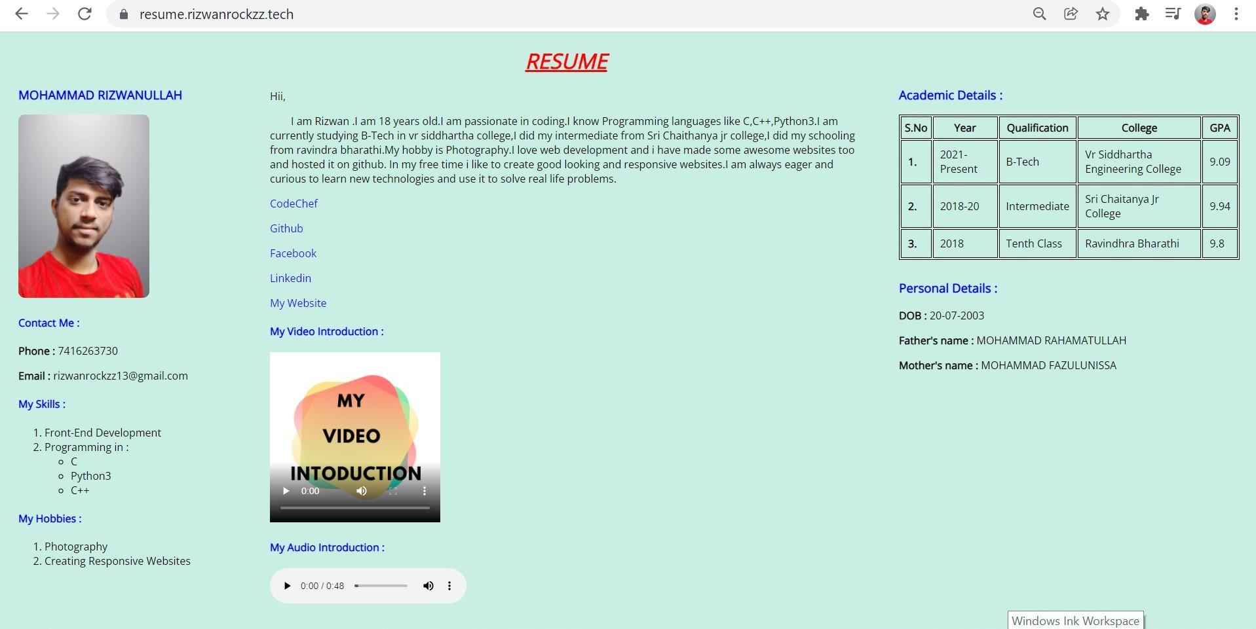

**WEEK-6:**

**Aim** : Prepare a resume application to collect the details of the Student

**Procedure:**

Tags Used**:**<label>,</label>,<input>,<form>,</form>

<!DOCTYPE html>

<html lang="en">

<head>

<title>HTML forms</title>

</head>

<body>

<center>

<h1>RIZWAN FORMS</h1>

</center>

<label for="firstname">First name &ensp;&nbsp;&emsp;&ensp;: &nbsp;</label>

<input type="text" id="fname" name="firstname" placeholder="John" required/><br /><br>

<label for="lastname">Last name &ensp;&nbsp;&emsp;&ensp;: &nbsp;</label>

<input type="text" id="lname" name="lastname" placeholder="Doe" required/><br /><br />

<label for="gender">Gender &ensp;&nbsp;&emsp;&emsp;&ensp;&ensp;: &nbsp;</label>

<input type="radio" id="male" name="gender" required/>

<label for="male">Male</label>

<input type="radio" id="female" name="gender" />

<label for="female">Female</label><br /><br>

<textarea name="address" rows="4" cols="30"></textarea>

<label for="dept">Department &ensp;&emsp;:&nbsp;&nbsp;</label>

<select id="branch" name="branch">

<option value="option">--- Select an option ---</option>

<option value="cse">CSE</option>

<option value="it">IT</option>

<option value="ece">ECE</option>

<option value="eie">EIE</option>

<option value="civil">CIVIL</option>

<label for="singing">Web Development</label>&ensp;<br>&emsp;&emsp;&emsp;&emsp;&emsp;&emsp;&emsp;&nbsp;&nbsp;

<input type="checkbox" id="dancing" name="dancing" value="dancing">

<input type="checkbox" id="photography" name="photography" value="photography">

<label for="photography">C</label>&ensp;<br>&emsp;&emsp;&emsp;&emsp;&emsp;&

</form>

</body>

</html>

**OUTPUT:**

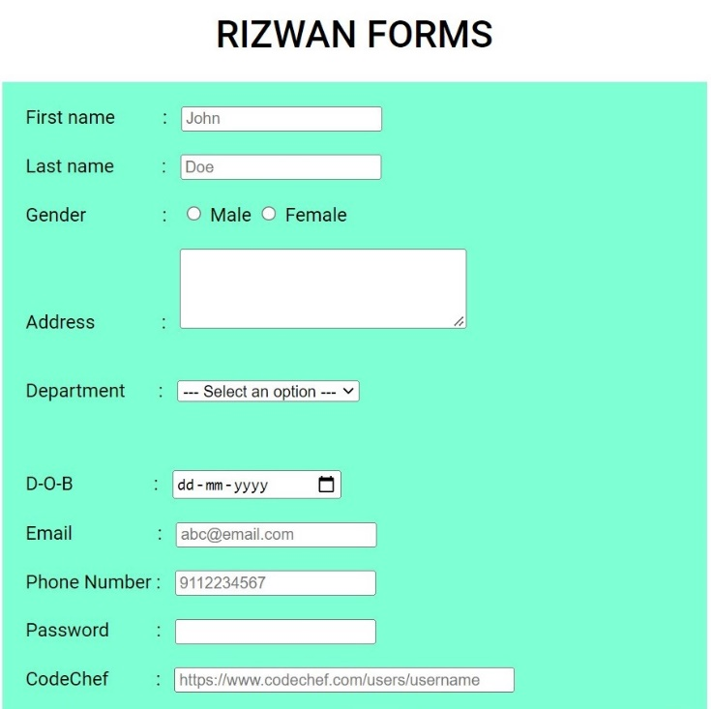

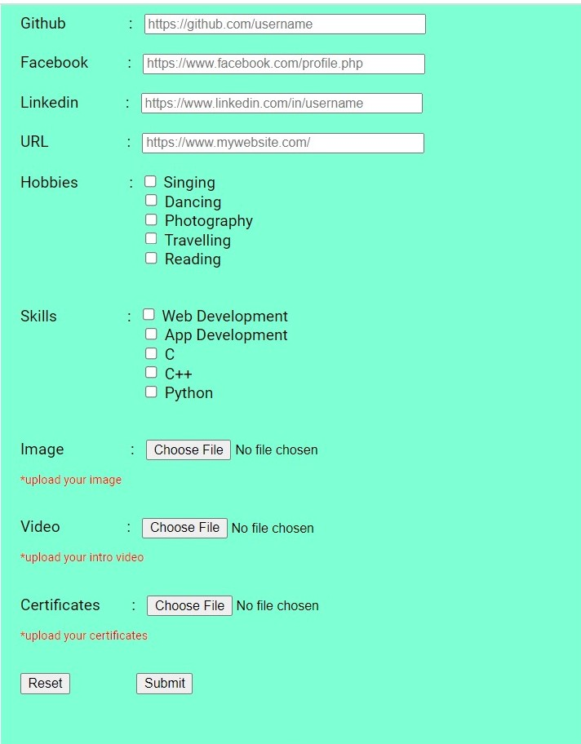

**WEEK 8**

**Aim**: create a website using HTML

**Code:**

<!DOCTYPE html>

<html lang="en">

<head>

<title>Foodie Plaza</title>

</head>

<body>

<!-- Navigaion Bar -->

<header>

<!-- <p class="logo">Foodie Plaza</p> -->

<img class="main-logo" src="images/logo.png" alt="logo">

<nav>

<ul class="nav-links">

<li><a href="index.html">Home</a></li>

<li><a href="#bring-about">About</a></li>

<li><a href="desserts.html" target="_blank">Desserts</a></li>

</ul>

</nav>

<button><a href="login.html" target="_blank">Login/SignUp</a></button>

</header>

<!-- Top Section -->

<div class="wrap-banner">

<div class="wrap">

<h1 class="tag">

The Fastest Delivery in <span class="theme-color">Your City</span>

</h1>

<h1 class="typing">Order Now : <span class="animate"></span></h1>

</div>

<img src="images/about.png" alt="food-illustration" />

</div>

<!-- Menu Section -->

<h3 class="sub-heading">Our Dishes</h3>

<h1 class="heading">popular dishes</h1>

<div id="bring-menu" class="grid-wrapper">

<div class="menu-item">

<img src="images/dish-1.png" alt="" />

<p class="item-name">Burger</p>

<div class="stars">

<i class="fas fa-star"></i>

<i class="fas fa-star"></i>

<i class="fas fa-star"></i>

<i class="fas fa-star"></i>

<i class="fas fa-star-half-alt"></i>

</div>

<p class="item-cost">₹ 249/-</p>

<button class="cart">

<a href="login.html" target="_blank">Add to cart</a>

</button>

<button class="cart">

<a href="login.html" target="_blank">Order now</a>

</button>

</div>

<div class="menu-item">

<img class="put-down" src="images/dish-2.png" alt="" />

<p class="item-name">Chicken Nugget</p>

<div class="stars">

<i class="fas fa-star"></i>

<i class="fas fa-star"></i>

<i class="fas fa-star"></i>

<i class="fas fa-star-half-alt"></i>

</div>

<p class="item-cost">₹ 199/-</p>

<button class="cart">

<a href="login.html" target="_blank">Add to cart</a>

</button>

<button class="cart">

<a href="login.html" target="_blank">Order now</a>

</button>

</div>

<div class="menu-item">

<img src="images/dish-3.png" alt="" />

<p class="item-name">Barbecue chicken</p>

<div class="stars">

<i class="fas fa-star"></i>

<i class="fas fa-star"></i>

<i class="fas fa-star"></i>

<i class="fas fa-star"></i>

<i class="fas fa-star-half-alt"></i>

</div>

<p class="item-cost">₹ 475/-</p>

<button class="cart">

<a href="login.html" target="_blank">Add to cart</a>

</button>

<button class="cart">

<a href="login.html" target="_blank">Order now</a>

</button>

<!-- Hungry Section -->

<div class="grid-banner">

<div>

<h3 class="sub-heading">Hungry!!!!</h3>

<h1 class="heading">Order Now..</h1>

</div>

<div>

<img src="images/loader.gif" alt="" class="center" />

</div>

</div>

</body>

</html>

**Login.html:**

<!DOCTYPE html>

<html lang="en">

<head>

<title>Login</title>

</head>

<body>

<div class="login-box">

<h2>Login</h2>

<form action="" class="form">

<div class="user-box">

<input class="input" type="text" id="" required="">

<label class="label" for="">Username</label>

</div>

<!-- /.user-box -->

<div class="user-box">

<input class="input" type="password" id="" required="">

<label class="label" for="">Password</label>

</div>

<!-- /.user-box -->

<a href="#">

<span></span>

<span></span>

<span></span>

<span></span>

Login

</a>

</form>

<!-- /form -->

<p class="sign-up">Don't have an account <a href="signup.html">Sign Up</a> here</p>

</div>

<!-- /.login-box -->

</body></html>

**OUTPUT:**

